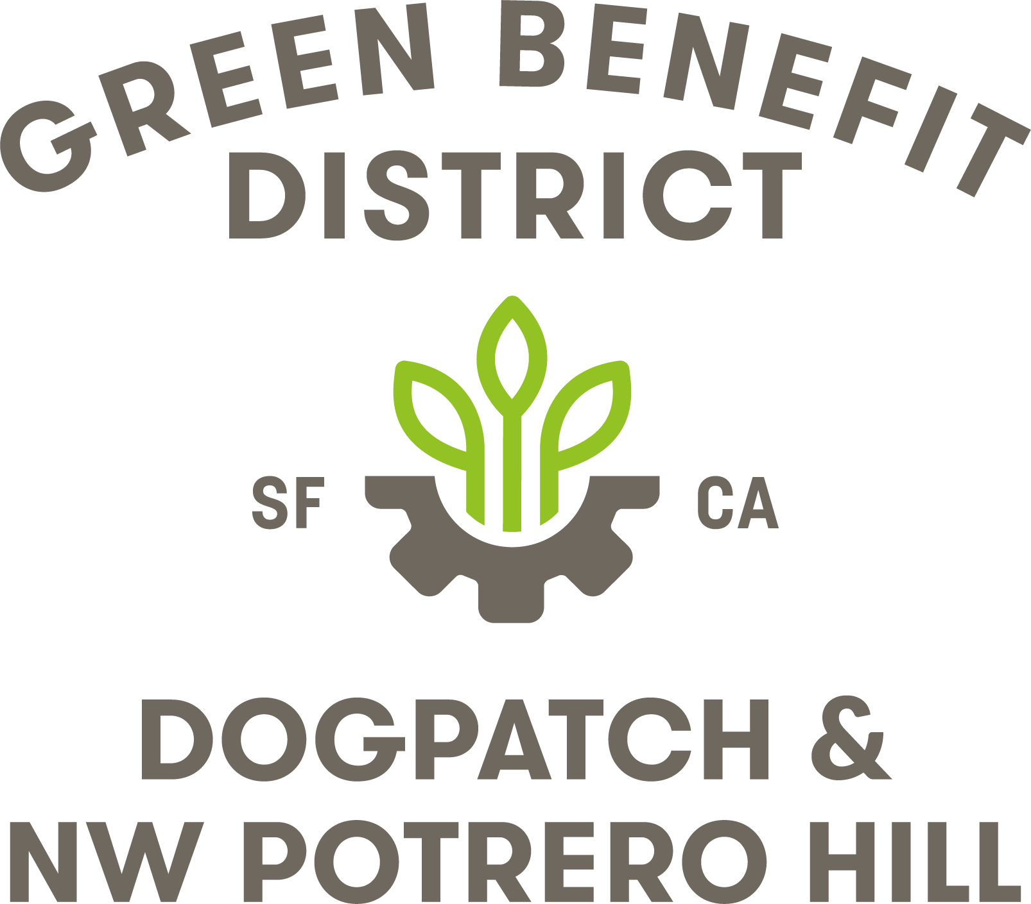

Dogpatch & Northwest Potrero Hill Green Benefit District
Board of Directors General Meeting
September 19, 2018, 6:30– 8:30 PM
654 Minnesota Street, San Francisco, CA 94107

Board Members In Attendance: Jean Bogiages, Janet Carpinelli, Kate Eppler, Susan Eslick, Jesse Herzog, Jim Naylor, Phillip Pierce, Kat Sawyer, Loren Swanson, Alison Sullivan
Board Members Excused: Keith Goldstein, Alex Goretsky, Bruce Huie, Jason Kelly Johnson
City Staff in Attendance: Jonathan Goldberg, SF Public Works
Executive Director: Julie Christensen

Minutes

1. Meeting Opened by President Jesse Herzog at 6:35

2. Roll Call and Approval of Minutes (Eppler)
Secretary Kate Eppler called roll.
VOTE: The August 2018 minutes were approved as amended by voice vote.

3. Announcements (All)
Treasurer Susan Eslick noted that the DNA block party had been rescheduled for Nov. 3. Alison Sullivan offered to organize the GBD’s booth at the event.
An Esprit park cleanup is scheduled for October 5, 11-1.
Phillip Pierce reported that SFMTA is surveying residents about route alternatives for the new 55 Dogpatch bus. The survey can be found at Bit.ly/55dogpatch
Kat Sawyer announced that the ThinkWalk water exploration would be October 7, and that there was room for community members to attend in addition to board members.

4. Public Comment for Items Not on the Agenda
There was no public comment for items not on the agenda.

5. Financial Report (Treasurer Eslick)
Eslick reported that the GBD’s books had been closed and submitted to the auditor, and that the GBD was on track to respond to the auditor’s 98 questions by the beginning of October.

6. Public Realm Plan (Guest Robin Abad)
Abad presented an overview of the Central Waterfront/Dogpatch Public Realm Plan. A vote on formal GBD recommendation of the plan was postponed until the next board meeting, to give all board members time to fully review the plan.

7. Esprit Park Update (President Herzog)
UCSF issued their draft of a grant agreement and the GBD’s attorney is reviewing it. After a meeting with UCSF and the Recreation and Parks department, it was agreed that Recreation and Parks would take over responsibility for leading community outreach on the project. Recreation and Parks Department will organize the next Esprit Community Advisory Group meeting to update the community.

8. Caltrain Station Complexity (Christensen)
In total, nine projects are happening around the area of the 22nd St. Caltrain station. David Fletcher and SOM are willing to do a concept development session that encomasses all work around the station and unifies it in a conceptual plan. Jason Kelly Johnson, Robin Abad and Jonathan Goldberg have agreed to participate.
VOTE: A motion to allocate up to $25k for the purpose of studying 22nd St. Caltrain station placemaking and wayfinding, and unifying disparate projects before the end of the fiscal year, was approved by voice vote.

9. ED Report (Christensen)
Christensen reported on progress around the district, including that fitness equipment had been installed at Progress Park and the accompanying concrete slab was being poured. GBD workers repaired a 22nd street sidewalk garden in front of Piccino that had been damaged during street renovations. The GBD annual report is with the layout team. SOM did a tweak of the GBD logo to make a circular version that will be easier to use.

10. Adjourn (Herzog)
Herzog adjourned the meeting at 8:15

